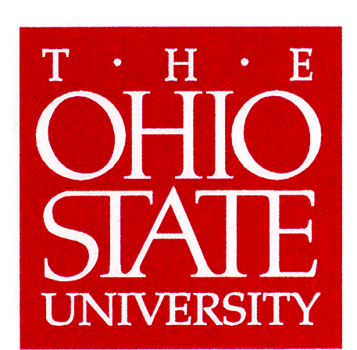
Division of Natural and Mathematical Sciences
______________________________________________________________________________________________

186 University Hall
230 North Oval Mall
Columbus, OH 43210

Phone (614) 292-8908
Fax (614) 247-7498

October 28, 2010

Larry Krissek
Chair, Arts and Sciences CCI

Dear Larry:

It is a pleasure to forward to you the proposal for the BS major in Physics under semesters. The major has been modified from its present quarter version mainly by reduction of the number of tracks offered and by the splitting of upper division courses in quantum mechanics and electromagnetic field theory into honors and non-honors versions to better meet the needs of the students. It is a solid proposal, well conceived.

Beyond my own review of the documents, the proposal has been discussed by colleagues from other NMS units at meetings on October 13 and 20, 2010. Feedback from these discussions has been incorporated in the proposal.

If you have any questions, I would be happy to address them.

Sincerely,

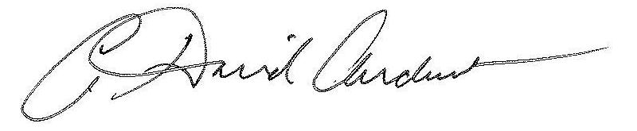

David Andereck
Professor of Physics
Associate Dean of Natural and Mathematical Sciences, College of Arts and Sciences

